6.1 Batteries in Solar PV Systems

Electrical storage batteries are usually used in PV systems, as the demand for energy does not always coincide with its production. The primary functions of a storage battery in a PV system are as follows:-

- Energy Storage Capacity and Autonomy: to store electrical energy whenever the PV modules produce it and supply energy to electrical loads as needed.
- Voltage and Current Stabilization: to supply power to electrical loads at stable voltages and currents by suppressing or “smoothing out” transients that may occur in the PV system.
- Supply Surge Current; to supply surge or high peak operating currents to electrical loads or appliances.

Battery Types and Classifications

Generally electrical storage batteries could be categorized into two main groups-Primary and secondary batteries.

Primary batteries can store and deliver electrical energy; but they cannot be recharged. Example of primary battery is dry cell used in radio, torchlight, watches etc.

Secondary batteries can store/deliver electrical energy as well as can also be recharged by passing a DC current through it in an opposite direction to the direction of discharge current. General examples of such batteries are common lead acid batteries used in automobiles and PV systems.

Battery Design and Construction

Battery manufacturing is an intensive heavy industrial process involving the use of hazardous and toxic materials. Some common components of the lead acid batteries are as follows (fig. 6.1.1):

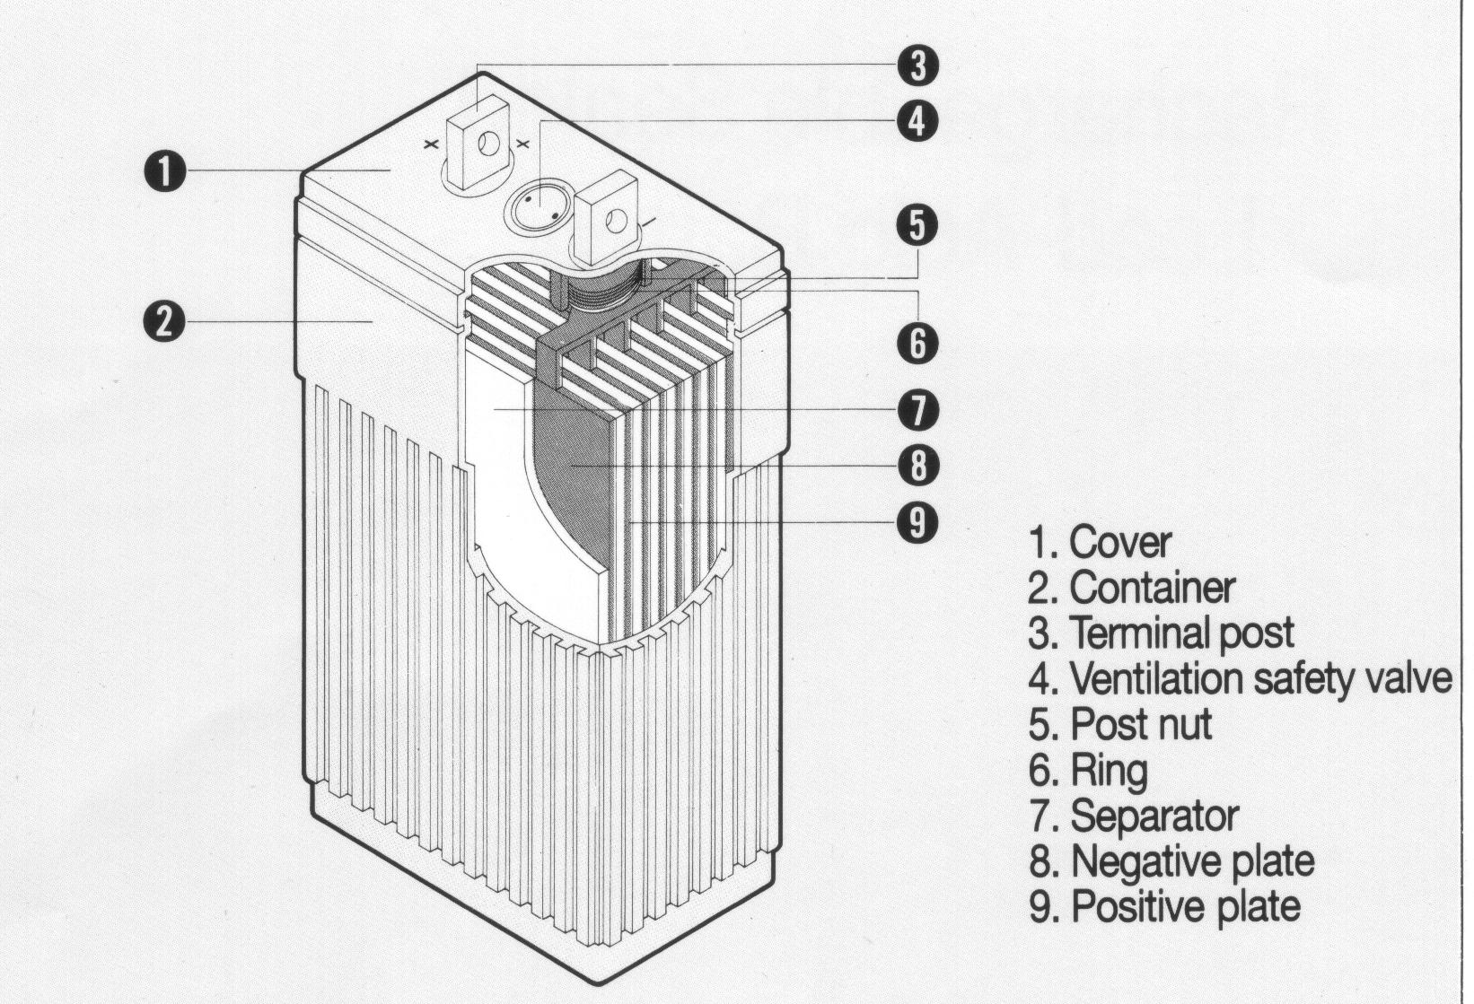
Fig.6.1.1 Construction of Battery

- Cell
The cell is the basic electrochemical unit in a battery consisting of a set of positive and negative plates divided by separators; which are immersed in an electrolyte solution enclosed in a case. In a typical lead-acid battery each cell has a nominal voltage of about 2.1 Volts. Therefore a 12-volt battery consists of 6 cells in series connection.

- Active Material
In lead-acid batteries the active materials are lead dioxide (PbO₂) in the positive plates and metallic sponge lead (Pb) in the negative plates. The amount of active material in a battery is generally proportional to the capacity that a battery can deliver.

- Electrolyte
An electrolyte is a conducting medium, which allows the flow of current through ionic transfer between plates in a battery. In a lead acid battery the electrolyte is a diluted sulfuric acid solution, either in a liquid (flooded) form, gelled or absorbed in glass mats. In flooded nickel-cadmium batteries the electrolyte is an alkaline solution of potassium hydroxide and water.

- Grid
In a lead –acid battery the grid is typically a lead alloy framework that supports the active material on a battery plate; and which also conducts current. Antimony and calcium are also used as alloying agents to strengthen the lead grids, which impart characteristic effects on battery performances such as cycle performance and gassing. Some grids are made of long spines of lead with the active material plated around them forming tubes; which are called as tubular plates.

- Plate
A plate, sometimes called as an electrode consists of grid and active material. A pasted plate is made by coating a mixture of lead oxide, sulfuric acid, fibers and water on the grid. The thickness of the grid and plate very much affect the deep cycle performance of a battery. Thin plates are generally used in automotive batteries, whereas thick plates are used in deep cycle batteries.

- Separator
A separator is a porous insulating divider between the positive and negative plates in a battery, which prevents the plates from coming into electric contact and short-circuiting; but allows the flow of electrolyte and ions between the positive and negative plates. Separators are generally made of micro-porous rubber, plastic or glass-wool mats.

- Element
An element is a stack of positive and negative plate groups and separators assembled together with plate straps interconnecting the positive and negative plates.

- Terminal Posts
Terminal posts are the external positive and negative electrical connections to a battery. A battery is connected in a PV system and to the electrical loads at the terminal posts. In lead-acid batteries the terminal posts are generally made of lead or lead alloy.

- Cell Vent
Cell vents allow the escape of gases produced inside the battery during charging process or permit addition of water if required. Each cell of a complete battery has some type of cell vent.

- Case
The plates, separators and electrolyte in a battery are contained in a typically enclosed case, generally made of plastic or hard rubber. Clear battery cases or containers allow easy monitoring of electrolyte levels and battery plate conditions.

Lead-Acid Battery Chemistry

During discharge cycle the battery is connected to an electrical load and current flows from the battery to the load. In this process the active materials are converted into lead sulfate (PbSO₄) as given by the following chemical equation:

Positive Plate Electrolyte Negative Plate Positive Plate Electrolyte Negative Plate

PbO₂ + 2H₂SO₄ + Pb → PbSO₄ + H₂O + PbSO₄

During battery charging the direction of chemical reaction is reversed as follows:

Positive Plate Electrolyte Negative Plate Positive Plate Electrolyte Negative Plate

PbSO₄ + 2H₂O + PbSO₄ → PbO₂ + 2H₂SO₄ + Pb

As the battery is discharged the active materials PbO₂ and Pb in the positive and negative plates respectively, combine with the sulfuric acid solution to form PbSO₄ and water. The dilution of the electrolyte has important consequences in terms of specific gravity and freezing point of the electrolyte.

- Formation
Formation is the initial process of battery charging during manufacture, when lead oxide (PbO) on the positive plate grids are changed to lead dioxide (PbO₂) and lead on the negative plates into metallic sponge lead (Pb). The need for additional cycles in the field to achieve the rated capacity of the battery depends upon the extent to which the battery has been formed during manufacturing

- Specific Gravity
Specific gravity is defined as the ratio of the density of a solution to the density of water. Specific gravity is typically measured by a hydrometer. By definition water has a specific gravity of one. In a fully charged lead-acid battery the electrolyte consists of about 36% sulfuric acid by weight or 25% by volume; and the rest is pure water. Specific gravity of the electrolyte is related to the battery state of charge, which depends upon the design electrolyte concentration and temperature.

According to the manufacturers of “VOLTA” brand deep cycle lead-acid batteries the specific gravity of electrolyte of such batteries should be in the range of 1.240 to 1,250 at 25°C. The state of charge and specific gravity of such batteries are tentatively as follows (Table 6.1.1):

Table 6.1.1 Specific gravity of cell and status of charge for Lead-acid battery

S.No. | Specific Gravity of Cell | Status of Charge
1. | 1.250 | Fully charged.
2. | 1.190 | 50% Charged
3. | 1.100 | Fully discharged

Specific gravity very much depends upon the temperature of the electrolyte. For every rise of 10°C above 25°C an amount of 0.007 should be added to the specific gravity reading at 25°C as temperature correction factor. Similarly for every fall of 10°C below 25°C a temperature correction factor of 0.007 should be deducted from the standard specific gravity reading at 25°C. The following table 6.1.2 explains this phenomenon.

Table 6.1.2 Variation of specific gravity with temperature

S.No. | Temperature | Specific Gravity Reading
1 | 15°C | 1.243
2 | 25°C | 1.250
3 | 35°C | 1.257

An electrolyte having a specific gravity reading of 1.250 at 25°C will show a reading of 1.243 at 15°C or will give a reading of 1.257 at 35°C.

While the specific gravity can be used to assess the state of charge of a lead acid battery, low or inconsistent specific gravity readings between series connected cells in a battery may indicate sulfation, stratification or lack of equalization between cells. In some cases a cell with a low specific gravity may indicate a cell failure or internal short-circuit within the battery. Therefore the measurement of specific gravity could be a valuable aid in the routine maintenance and diagnosis of battery problems in solar PV systems.

- Sulfation
Sulfation is a normal process that occurs in lead acid batteries resulting from prolonged operations at partial state of battery charge. During sulfation lead sulfate crystals grow up on the positive plates, and reduce the chemically active area and thus capacity of the cell. During normal battery discharge the active materials of the plates are converted into lead sulfate. The deeper the discharge is, the greater the amount of active material that is converted into lead sulfate. During recharge the lead sulfate is converted into lead dioxide and sponge lead on the positive and negative plates respectively. If the battery is recharged soon after being discharged, the lead sulfate converts easily back into active material.

However if a lead-acid battery is left at less than full state of charge for prolonged period (say days or weeks) the lead sulfate crystallizes on the plate and retards the conversion back to active material during recharge. The crystals essentially “lock away” active material and prevent it from reforming into lead and lead dioxide; which consequently reduces the available total capacity of the battery. If the lead sulfate crystal growth is too large, plates could be physically damaged. Sulfation also causes higher internal resistance within the battery making it more difficult to recharge.

Sulfation is a common problem experienced with lead-acid batteries in PV systems. To minimize the sulfation of lead-acid batteries the PV array should be designed to recharge the battery bank on the average daily conditions during the worst insolation month of the year

- Stratification
Stratification indicates the condition of a flooded lead-acid battery in which the specific gravity/concentration of the electrolyte increases from the bottom to the top of the cell. Undercharging or not providing enough overcharge to gas and agitate the electrolyte during finishing charges can cause stratification. Prolonged stratification can result into the bottom of the plate being consumed, while the upper portion remaining in relatively good shape. This ultimately leads to the reduction in the capacity and life of the battery. Periodic equalization charges can prevent stratification problem.

Battery Terminology and Performance Characteristics

- Ampere-Hour (Ah)
An ampere-hour is equal to the transfer of 1 amp over a period of 1 hour and is equal to 3,600 coulombs of charge. For example a battery, which delivers 7 Amperes for a period of 10 hours is said to have delivered 70 Ampere-hours.

- Capacity
Capacity refers to the ability of a battery to store or deliver electrical energy. It is commonly expressed in Ampere-hours. Usually the capacity of a battery in Ah is given for particular discharge rate. Slower the discharge rate, higher will be the capacity of the battery. The capacity of a battery depends upon the following factors:

- Design factors such as the quantity of active material; the number/design/physical dimensions of plates; the specific gravity of electrolyte, etc.
- Operational Factors such as discharge rate, depth of discharge, cut-off voltage, temperature, age, cycle history of battery, etc.

Lower operational temperature generally reduces the rated capacity of a battery.

The graph in fig. 6.1.2 relates the battery capacity correction factor for different temperatures.
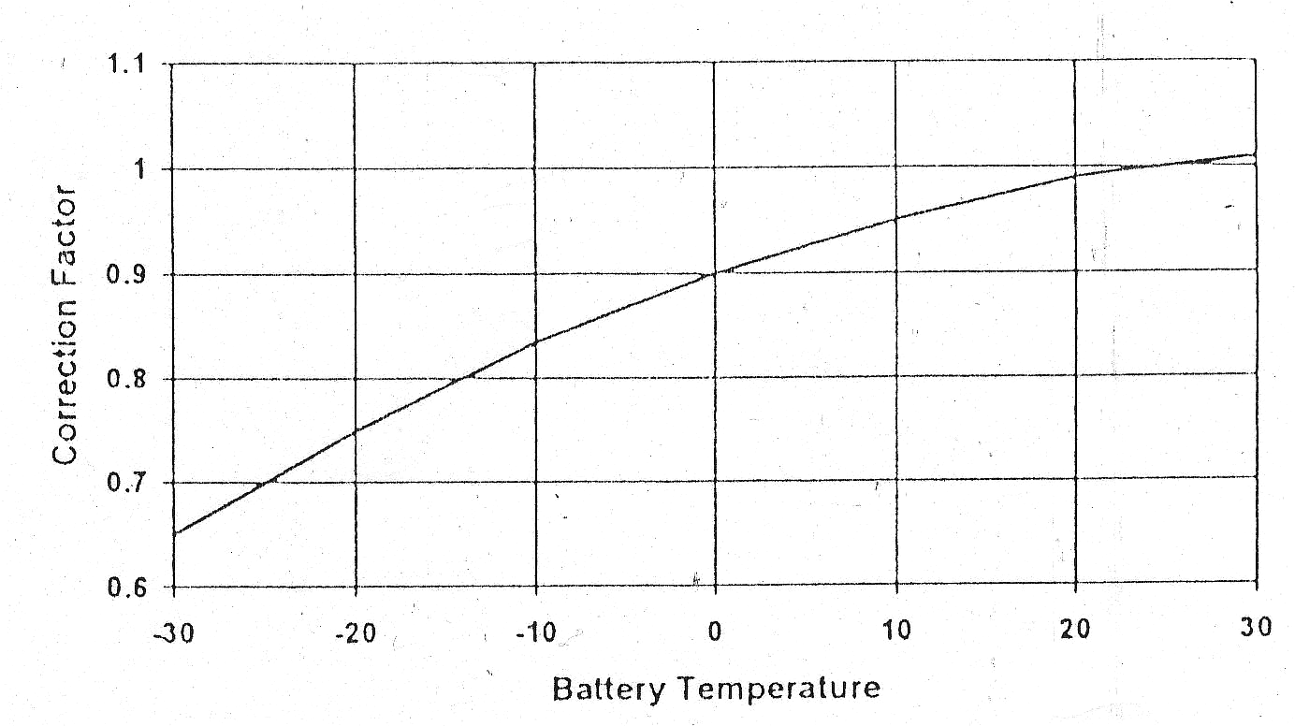
Fig. 6.1.2 Battery capacity correction

- Open Circuit Voltage
Open circuit voltage is the voltage of the battery at rest or in steady state and which is not in the charge or discharge cycle. Depending upon the design, specific gravity and temperature of the battery the open circuit voltage of a fully charged battery is about 2.1 volts per cell.

- Cut-off Voltage
Cut-off voltage is the lowest voltage, which a battery system is allowed by the manufacturer to reach in operation. Manufacturers often rate battery capacity to a specific cut-off or end-point voltage at a defined discharge rate.

- Terminal Voltage
Terminal voltage is the voltage between the positive and negative terminals of a battery either during charge or discharge cycle.

- Cycle
Cycle refers to a discharge to a given depth of discharge followed by a complete recharge. Life of the battery is measured in number of cycles.

- Rate of Charge/Discharge
The rate of charge or discharge of a battery is expressed as a ratio of the nominal battery capacity to the charge/discharge time period in hours. For example, a 5-Ampere discharge for a nominal 100 ampere-hour battery would be considered as a C/20 discharge rate.

- State of Charge
The state of charge (SOC) refers to the amount of energy in a battery expressed as a percentage of the total energy stored in a fully charged battery. A battery that has been discharged 60% is said to be at 40% state of charge.

- Depth of Discharge
The depth of discharge (DOD) is the percentage of capacity that has been withdrawn from a battery compared to its total fully charged capacity. By definition the depth of discharge and the state of charge of a battery total 100 percent.

- Allowable Depth of Discharge
The maximum percentage of full rated capacity that could be withdrawn from a battery is known as its allowable depth of discharge. Allowable DOD depends upon the design cut-off voltage and discharge rate. In stand-alone PV systems the low voltage load disconnect set point of the battery charge controller dictates the allowable DOD limit at a given discharge rate. Depending upon the type of battery used in a PV system the design allowable DOD may be as high as 80% for deep cycle batteries or as low as 15% to 25% for SLI batteries.

The allowable depth of discharge also depends upon the autonomy of battery bank, i.e. upon the capacity required to operate the system loads for a given number of days without energy input from the PV modules. The higher the discharge rate or current withdrawal the lower is the capacity that can be withdrawn from a battery to a specific allowable DOD or cut-off voltage. Higher discharge rates also result in the terminal voltage to be lower than that with lower discharge rates, sometimes affecting the LVD set point.

The maximum allowable DOD is also a function of ambient temperature (fig.6.1.3). With decrease in temperature the level of allowable DOD decreases substantially.

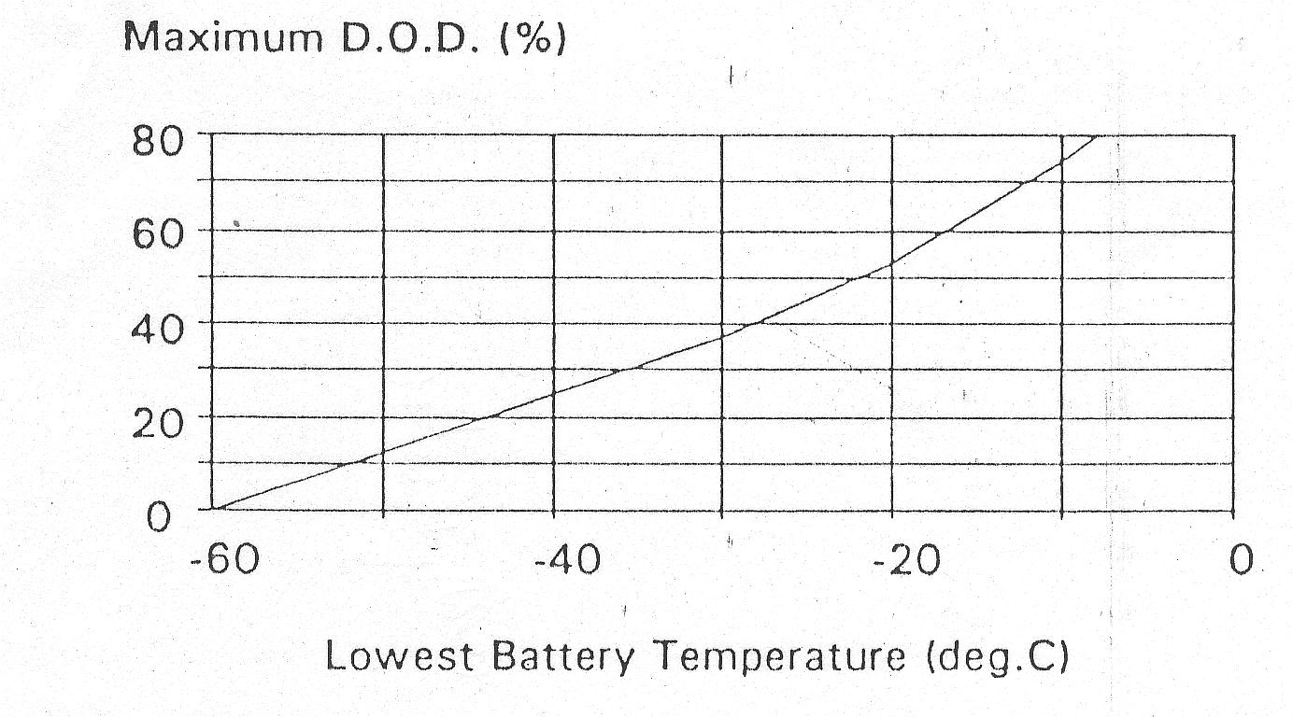
Fig. 6.1.3 Maximum DOD as a function of temperature

Autonomy
In a stand-alone PV system autonomy refers to the time a fully charged battery can supply required energy to the system loads when there is no energy supplied by the PV modules. For common and less critical PV systems the autonomy period ranges from two to five days.

Self-discharge Rate
Even in open circuit mode (i.e., without any charge or discharge cycle) a battery undergoes reduction in its state of charge primarily due to the internal mechanisms and losses within the battery itself. Different types of batteries have different self-discharge rates. Higher temperatures generally contribute to higher discharge rates particularly for lead-antimony type of batteries.

Temperature Effects
Higher operating temperatures accelerate corrosion of the positive plate grids causing greater gassing and electrolyte loss in the battery. Lower operating temperature generally increases the battery life; however the battery capacity is significantly reduced at lower temperatures, particularly for the lead-acid batteries. Whenever severe variations in the operating temperatures exist, batteries should be located in an insulated enclosure to minimize the battery temperature swings.

Corrosion
Immersion of two dissimilar metals in an electrolyte or in direct contact of the dissimilar metals cause one material to undergo oxidation or lose electrons and at the same time cause the other material to undergo reduction, i.e., gain electrons.

Corrosion of grids supporting the active material is naturally an on-going process and may finally dictate the useful life of a battery. Battery terminals also undergo corrosion due to the action of electrolyte gassing from inside the battery. Therefore flooded type lead-acid batteries generally require periodic cleaning and tightening of the terminal posts

Battery Gassing
Gassing takes place during recharging when the battery is nearly fully charged. At this point the cell voltage rises sharply. In flooded type lead-acid batteries the gasses are releases from the cell vents and contribute to water loss. In sealed or valve regulated (i.e. maintenance-free) batteries however an internal recombinant process causes the reformation of water from the hydrogen and oxygen gasses generated under normal charging condition; as such no electrolyte maintenance is required. All gassing reactions consume a portion of the charging current, which cannot be delivered on the subsequent discharge, thereby reducing the efficiency of battery charging. Some degree of gassing is required to agitate and prevent stratification of the electrolyte, particularly in flooded type lead-acid batteries. When a flooded lead-acid is charged heavy particles of sulfuric acid form over the surface of the plates; and afterwards fall to the bottom of the battery. Over time the electrolyte stratifies and develops greater concentration of the acid at the bottom of the battery than at the top. If left unmixed the reaction process could be different from the bottom to the top of the plates. By gently gassing the flooded batteries the electrolyte is thoroughly mixed, thereby preventing the stratification of the electrolyte. However excessive gassing and overcharging could result in the break-up of active material from the grids, consequently reducing the life of the battery. Excessive gassing could also cause higher temperature leading to accelerated corrosion of the grids and thereby shortening the battery life.

Recommended typical charge regulation voltages (at 25°C) are given below (Table 6.1.3); however specific battery manufacturers should be consulted for their suggested values.

Table 6.1.3 Recommended Charge Regulation Voltages

 | Flooded Lead- Antimony Battery | Flooded Lead- Calcium Battery | Sealed Valve Regulated Lead-Acid Battery
Per cell | 2.40 – 2.47 | 2.33 – 2.40 | 2.33 –2.40
Per nominal  12 Volt battery | 14.4 – 14.8 | 14.0 – 14.4 | 14.0 – 14.4

The fig. 6.1.4 below illustrates the cell voltage, specific gravity, Ampere-hours delivered to load and drawn from the battery during the charging and discharging process of a lead-acid battery.

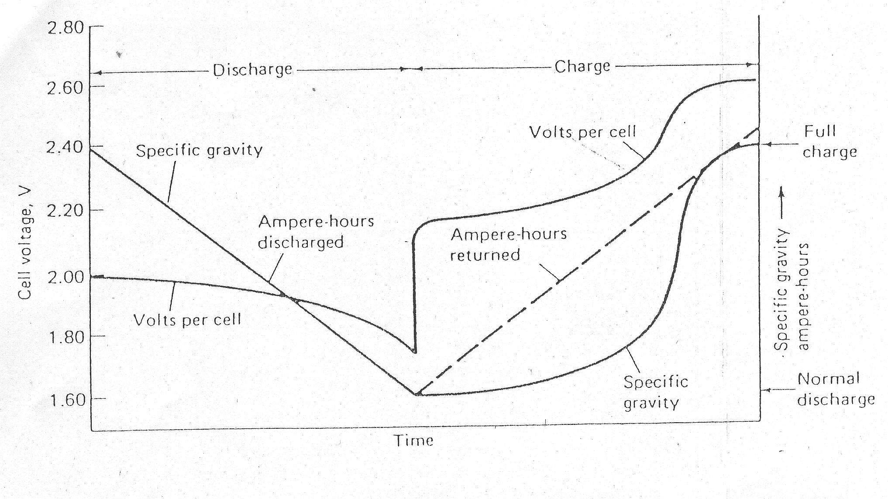
Fig. 6.1.4 Typical voltage and specific gravity characteristics of a lead- acid battery

Battery Charging
Battery manufacturers often refer to the following the modes of battery charging: -

Bulk or Nominal Charging
Bulk or nominal charging is the initial portion of a charging cycle, performed at any charge rate, which does not cause the cell voltage to exceed the gassing voltage. Such charging takes place generally between 80% and 90% of the state of charge.

Float or Finishing Charging
Once a battery has been nearly fully charged most of the active material in the battery will be converted into its original form. Then the voltage and/or current regulation are generally required to limit the amount over overcharge supplied to the battery. Finishing charges are generally conducted at low charge rates.

Equalizing Charge
Equalizing charges are periodically conducted to maintain consistency among the individual cells of a battery. Such charge generally consists of current-limited charge to higher voltage limits than set for the float charge; and is generally maintained until the cell voltages and specific gravities remain consistent for a few hours. For batteries deeply discharged on a daily basis an equalizing charge is recommended in every 1 or 2 weeks. For other types of battery discharges it could be conducted every one or two months depending upon the nature and depth of the battery discharge.

General Classification of Lead-Acid Battery

Many types of lead-acid batteries are used in PV systems, each having specific design and performance. Generally they are one of the following three categories.

SLI Batteries
Starting, lighting and ignition (SLI) batteries are lead-acid batteries primarily designed for shallow cycle services and mostly used to power automotive starters. The large number of plates per cell of such battery enables it to deliver high discharge currents for short periods. However they are not suitable for long life under deep cycle services. In developing countries SLI batteries are sometimes used in PV systems, where only one type of locally manufactured battery is available or when the difference in the up-front cost of the deep cycle battery and SLI battery is very high. Although generally not recommended in most PV applications, SLI batteries may provide 2 or more years of useful services in small stand-alone PV systems, where the average daily depth of discharge (DOD) is limited to 10% to 20% and the maximum allowable DOD is limited to 40% to 50%.

Motive Power or Traction Batteries
These batteries are designed for deep discharge cycle services as generally required in electric vehicles or forklifts, etc. Such batteries have a fewer number of plates per cell than SLI batteries, however the plates are made much thicker and constructed more durably. These types of battery are also very popular in PV systems due to their deep cycle capabilities and longer life cycles

Stationary Battery
Stationary batteries are used commonly in un-interruptible power supplies (UPS) to provide back-up power to computers, telecommunication equipment, etc. These batteries are designed for deep discharge and limited cycle service; and they are commonly float charged continuously.

Captive Electrolyte Type of Special Lead-Acid Battery

Valve Regulated Lead-Acid Battery
Valve regulated lead-acid (VLRA) batteries are captive electrolyte type of lead-acid batteries where the electrolyte is immobilized by means of specially designed pressure regulating mechanism on the cell vents; and the battery is sealed under normal operating conditions. Electrolyte cannot be generally replenished on these types of battery; therefore, they should not be subjected to excessive overcharge

Gelled Battery
In gelled lead acid batteries the electrolyte is specially ”gelled” by adding silicon dioxide in the electrolyte. Cracks and voids develop within the gelled electrolyte during the first few cycles, which provide path for gas movement between the positive and negative plates, facilitating the recombinant process.

Absorbed Glass Mat Batteries
In absorbed glass mat (AGM) type lead-acid batteries the electrolyte is absorbed in glass mats, which are sandwiched in layers between the plates. Under condition of controlled charging the pressure relief vents in AGM batteries are designed to remain closed, preventing the release of any gasses and water loss.

The above mentioned batteries are costlier than the flooded lead-acid batteries; and are used in special applications only, for example as a battery bank in low temperatures to avoid freezing of the electrolyte as found in flooded type lead-acid batteries.

Modern Rechargeable Batteries

Nickel-Cadmium Rechargeable Battery
In nickel cadmium rechargeable batteries nickel oxyhydroxide (NiOOH) is generally the active material in the charged positive plate and cadmium metal is the active material in the charged negative plate of the battery. The primary cell voltage is commonly 1.2volts. These batteries have found diverse applications in consumer and electronics market. For the same capacity range they are quite costlier than the similar lead-acid batteries; although they have a longer life cycle and higher allowable DOD. The main disadvantages of nickel cadmium batteries are the following aspects:
- It has got memory effect.
- It is environmentally hazardous as it contains toxic material viz. cadmium.

Nickel Metal Hydride Rechargeable Battery
The basis of this latest metal hydride technology is the ability of certain metallic alloys to absorb the smaller hydrogen atoms in the interstices between the larger metal atoms. As in nickel cadmium battery generally nickel hydroxide is used as positive electrode and aqueous potassium hydroxide is used as electrolyte. But in place of cadmium metal hydride alloys as used as active material for the negative electrode of the cell. The primary cell voltage is 1.2 Volt. As compared to Ni-Cd batteries NiMH batteries are initially costlier; but their energy density is about 20% to 30% higher than similar NiCD batteries; and they have longer life cycles. These batteries do not have memory effect and are considered as environmentally friendly. They do not pose any serious disposal problem. If fact these batteries are now rapidly replacing the market of Ni-Cd batteries.

Lithium Ion Battery
Lithium ion batteries use lithium compounds and are rechargeable. They have a higher energy density than even NiMH batteries; and posses a primary cell voltage of about 3.7 Volts. They have a lower self-discharge rate and are quite environmentally friendly. But as compared to any other type of rechargeable batteries they are still costlier.

The table 6.1.5 below provides quick reference to the merits and demerits of different types of batteries used in solar PV system.

Table 6.1.5 Comparison of different types of batteries

Type of battery | Merits | Demerits
Flooded Lead-Acid battery (LSI type) | - Widely available  - Low cost  - Good for automotive use | - Shallow cycle  - Heavy weight  - Very poor cycle life  - Contains toxic element
Flooded Lead-Acid battery (Modified LSI type) | - Deep cycle  - Good for use in solar PV system and electric traction vehicles | - Heavy weight  - Poor cycle life  - Costlier  - Contains toxic element
Flooded Lead-Acid battery (Tubular plate type) | - Improve deep cycle  - Better for use in solar PV system and electric traction vehicles | - Heavy weight  - More costlier  - Contains toxic element
Nickel Cadmium battery | - Long cycle life  - Deep cycles  - Withstand harsh environment | - Expensive  - Memory effect  - Contains toxic element
Nickle Metal Hydride battery | - Prolonged cycle life  - Deep cycles  - Better performance in cold climate  - Light weight  - Lower operating cost  - Non-toxic  - No memory effect | - Up-front cost very high

Methods of Battery Charging
Charging lead-acid or any other types of secondary batteries is a matter of replacing the energy depleted during the discharge cycle. Charging may be accomplished by various methods; but the objective of driving current through the battery in the direction opposite to that of the discharge remains the same.

Constant –Current Charging
In constant current charging the charger provides a relatively uniform current regardless of the state of charge or temperature of the battery. Constant current charging assists to eliminate any charge imbalance in the battery, especially when several cells/batteries are charged in series.

Constant-Voltage Charging
Constant voltage/potential charging is the most common method of charging secondary batteries. In this mode of battery charging the charger voltage is held uniform regardless of the battery state of charge. The charge current is initially greater; but as battery gets recharged the charge current declines or tapers down. PV modules basically act as constant- voltage chargers.

Charge Acceptance
Charge acceptance (i.e., efficiency) is the term used to describe the efficiency of the battery. No battery is 100% efficient. A 90% charge acceptance means that for every one ampere-hour of charge introduced into the battery or cell, the battery or cell will be able to deliver 0.9 ampere-hour of current to the load during discharge cycle. The charge acceptance of lead-acid batteries may be higher than 85%. Charge acceptance is affected by a number of factors including cell temperature, state of charge, age of cell, charge current, method of charging, etc.

Battery Auxiliary Equipment

Enclosures
Batteries should be preferably installed in suitable enclosures that are insulated or could have passive heating/cooling devices to protect the batteries from excessive temperatures. If the enclosure is located above ground some type of shading should be provided.

Ventilation
Batteries often produce gases namely hydrogen. Passive ventilation techniques such as vents or ducts should be provided.

Catalytic Recombination Caps
A substitute for standard vent caps on lead acid battery is the catalytic recombination caps (CRC) whose main function is to reduce electrolytic loss from the battery. CRC contains particles of platinum or palladium, which absorbs hydrogen generated from the battery during finishing or overcharge cycles. The hydrogen is again combined with oxygen in the CRC to form water, which drains back into the battery.

Battery Test Equipment

Hydrometer
Hydrometer is used to measure the specific gravity of electrolyte of lead-acid batteries. As mentioned earlier the specific gravity of electrolyte is closely related to the state of charge of the battery. Hydrometer should be calibrated preferably at 25°C. If possible properly calibrated and tested battery hydrometers only should be used in PV systems. When measurements are taken from the electrolyte at other temperatures a correction factor as described above must be applied.

Voltmeter
Analog or digital type voltmeter (or multimeter) is generally used to measure the terminal voltages of batteries.

Load Tester
A battery load tester is an instrument, which draws current from a battery with an electric load, while recording the voltage. Although not designed for measuring capacity it may be used to determine the general health or consistency among the batteries in a system. Load test data generally express a discharge current over a specific time period.

Battery Maintenance

The maintenance requirement for lead-acid batteries varies significantly depending upon the type, design and application of the battery. Maintenance recommendations provided by the specific battery manufacturer should be properly studied and followed. Maintenance considerations should include cleaning of cases, terminals and cables, tightening terminals, coating of terminals by petroleum jelly, water addition and performance checks. Water should be distilled or de-mineralized or de-ionized, having a pH value of 6.5 to 7 and a conductivity of 2 to 6 micro-siemens (μs). Performance checks may include recordings of specific gravity, temperature measurements, cell voltage readings or even a capacity test.

Battery Safety Considerations

Handling Electrolyte
Sulfuric acid of the electrolyte can destroy clothing and burn the skin. For these reasons protective clothing such as acid-proof apron, and face shields should be worn by personnel working with the battery, If required acid should be poured slowly into the water while mixing. The water should never be poured into the acid. Appropriate non-metallic funnels and containers should be used when mixing electrolyte solution.

To neutralize sulfuric acid spills or splashes on clothing, the spill should be rinsed immediately with a solution of baking soda and water. If electrolyte is accidentally splashed in the eyes, the eyes should be forced open and flood with clean water for at least 15 minutes. If necessary a doctor should be consulted.

Personnel Protection
When performing battery maintenance, personnel should wear protective clothing such as aprons, ventilation masks, goggles or face shields and acid-proof gloves to protect from acid spills or fumes. Jewelry on the hands and wrists should be removed and properly insulted tools should be used to protect against inadvertent battery short-circuits.

Dangers of Explosion
During operation batteries may produce explosive mixture of hydrogen and oxygen gases. Keep spark, flames, burning cigarettes, kerosene lamps or other ignition sources away from the batteries at all times. While making or breaking connections to a battery from a charging source or electrical load, it should be checked and ensured that the charger or load is switched off so as not to create sparks or arcing during the connection.

Battery Disposal

Batteries are considered as hazardous item as they contain toxic materials such as lead, acids and plastics that can harm human beings and the environment. If recycling facilities exist, deliver the complete battery with electrolyte to the recycling organization or to their scrap dealers. Under no circumstances should the batteries be disposed off in the landfills or near the water springs and resources. The electrolyte should not be allowed to seep into the ground and the battery should not be burned.

